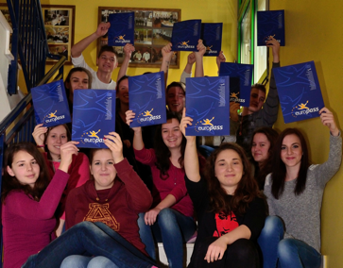

This project has been funded with support from the European Commission. This publication reflects the views only of the author, and the Commission cannot be held responsible for any use which may be made of the information contained therein.
CONTENTS

1. Personal data
2. Sending institution contact data
3. Receiving institution contact data
4. Host company contact data
5. Accommodation data
6. Work placement data
7. Self-assessment checklists
8. Dossier
9. Appendices

Introduction

The main purpose of the International Work Placement Portfolio is to keep all important data, documents and collected materials related to your mobility experience abroad in one single place.
It is very useful to start collecting the materials in your IWP Portfolio from the very beginning. After the work placement, you are expected to write different reports. You may be asked to make a presentation at your home institution or you may decide for another international work placement in the future. Completing and/or updating your IWP Portfolio regularly will enable you to find any information or document related to your past mobility experience quickly and easily if you need it.
The self-asssessment checklists for language and professional skills can be attached to your Europass CV when applying for a job or another international work placement.
You can personalize your IWP Portfolio by creating cover pages with photos and lists of collected materials for all sections in the Dossier.
Some samples and tips for the self-assessment checklists and cover pages with lists for the Dossier are attached in appendices.

Use it- Don't lose it!
Make your IWP an unforgetable professional and personal experience !

PERSONAL DATA
First name and surname
Gender
Date of birth
Place of birth
Address
Street, number
Postal code, city
Country
Mobile phone
E-mail
Home institution
Name (original and in English)
Address
Street, number
Postal code, city
Country
Web page
E-mail
Skype name
Field of Study
Year
Language skills
Mother tongue
Foreign language, level ( A1- C2) (add boxes for more languages)

SENDING INSTITUTION CONTACT DATA
Sending organisation
Name
Address
Street, number
Postal code, city
Sending coordinator
First name and surname
Phone number
Mobile phone
E-mail
Skype name
Contact hours
Days, time (from…to…)
Accompanying teacher ( contact data during the work placement)
(Fill in if applicable)
First name and surname
Address
Street, number
Postal code, city
Phone number
Mobile phone
E-mail
Skype name

RECEIVING INSTITUTION CONTACT DATA
Receiving organisation
Name
Address
Street, number
Postal code, city
Web page
E-mail
Receiving coordinator
First name and surname
Phone number
Mobile phone
E-mail
Skype name
Contact hours
Days, time (from…to…)

Emergency phone numbers
Embassy of my country
Police
Firemen
Ambulance
Doctor/hospital

HOST COMPANY CONTACT DATA
Name
Address
Street, number
Postal code, city
Web page
E-mail
Work placement mentor
First name and surname
Address
Street, number
Postal code, city
Phone number
Mobile phone
E-mail
Skype name
Contact hours
Days, time (from…to…)
Travel Details (from the place of accommodation to the host company)
Travel to host company | From  (departure station) | To  (arrival station) | Travel time
By bus (number, bus company)
By train (name or direction)
Other

ACCOMMODATION - CONTACT DATA
Name of the hotel/hostel/B&B
Address
Street, number
Postal code, city
Website
(if applicable)
Phone number
Mobile phone
E-mail
Contact person, landlord
First name and surname
Phone number
Mobile phone
E-mail

WORK PLACEMENT DATA
Name of the Company /enterprise
Department
Mentor
Workplace assigned
Dress code
Main tasks
If you work at different departments copy this box for each work place.

Workplan - schedule
WEEK 1 | Working time  from to |  | Department
Monday
Tuesday
Wednesday
Thursday
Friday
Saturday
Sunday
Copy this box for each week of your IWP.

My new colleagues/work team members
Department 1:
Name (title) | Position /title | Contact (mobile, e-mail)
Department 2:
Department 3:

SELF-ASSESSMENT CHECKLIST 1
Language skills
Everyday language | Description of skills | Tick
Topic 1
Topic 2
Topic 3
Topic 4
Topic 5
Professional language

Topic 1
Topic 2

Topic 3
Topic 4
Topic 5

TIP: See Appendix 1 for a sample self-assessment checklist for IWP in a hotel and more tips where to find skills descriptions for everyday language and some sector-specific portfolios.

SELF-ASSESSMENT CHECKLIST 2
Professional skills
General | Description of skills | Tick
Department 1:
Department 2:
Department 3:

TIP: See a sample checklist in Appendix 2. You should include the professional skills from your Learning Programme and from the descriptions of your workplace(s) in the host company. Add any skills you acquired additionally eg by rotating through different departments of your host company, by stepping in for a co-worker, or by assisting the company staff for a special event or activity.

DOSSIER

The Dossier is a collection of all materials gathered during your mobility period, including:

- MOBILITY DOCUMENTS such as :
Europass CV, Letter of Motivation/Letter of Application, Learning Agreement, Europass Mobility, Letters of Recommendation, Certificates etc.

- MATERIALS ABOUT THE HOST COUNTRY such as:
Flyers, brochures, DVDs, event calendar, your photos of the countryside, sights, favourite places for socializing, photos of cultural events visited etc.

- MATERIALS ABOUT THE HOST COMPANY such as :
Brochures, photos, organisation structure, policy and values of the company, business cards, promotional material for products and/or services etc.

- WORKPLACE-RELATED MATERIALS such as:
Instructions for work, work safety regulations, descriptions of new methods of work, photos of products/machines, demonstrations, videos, personal dictionary of professional language used in the workplace.

Appendix1
SAMPLE SELF-ASSESSMENT CHECKLIST 1

Language skills (example for an IWP in a hotel)
Everyday language | Description of skills | Tick
Greetings | I can understand greetings and respond to them
 | I can introduce myself (give my basic personal data )
 | I can address people properly using the titles (Mr, Ms, or the title denoting his position at work
 | I can tell someone I don’t understand and ask someone to repeat or demonstrate it
 | I can apologise or express regret using phrases like ‘I am sorry’, ‘Excuse me’, ‘I regret’….
Time | I can understand and tell time using numbers, days of the week and months
 | I can tell time using numbers, days of the week and months
Place | I can understand basic information about places
 | I can ask basic information about places (like ‘Where is…’, ‘Where….from ?’, ‘Where…to?’.....)
 | I can understand and name the most important buildings in the city (post office, bank, bus station, railway station, hospital, pharmacy,etc
Orientation | I can understand simple questions and sentences about finding the way to different destinations in the city, etc
Professional language
Ingredients, materials | I can understand and name the most frequently used basic ingredients to prepare dishes (types of fruit, vegetables, meat)
 | I can understand and name the most popular herbs and spices used in the cuisine of the host country
Utensils and machines | I can understand and name the most frequently used utensils and machines in the kitchen
Methods of work | I can understand and describe the basic methods of preparing dishes like: cutting, slicing, grinding, grating cooking, braising, roasting, grilling, gratinating, frying etc
Communication at work  (useful phrases) | I can understand simple instructions related to my tasks in the hotel, kitchen and/or restaurant
 | I can use simple questions and answers to communicate with the members of my team about task-related topics
 | I can answer questions from guests related to the products and services of the hotel

TIPS:
You can create your own Can-do sentences before the work placement and later add new descriptions of your language skills developed during the placement.
You can include the skills descriptions from your programme for linguistic preparation (a language course at home or in the host country) or select relevant language skills descriptions from the self–assessment grid of the CEFR (Common European Framework of Reference for Languages) :
www.coe.Int/lang-CEFR and
http://www.coe.int/t/dg4/education/elp/elp-reg/Source/assessement_grid/assessment_grid_english.pdf

For VET Catering and Hospitality IWPs:
You can find more detailed language-skill descriptions for the gastronomy and reception sector in the Eurocatering Language Portfolio which also includes descriptions of intercultural skills and video clips with non- verbal communication.
http://www.eurocatering.org/media/tray/language_portfolio/1/EuroCatering_Language_Portfolio_K.pdf and
http://www.eurocatering.org/media/tray/language_portfolio/2/language_portfolio_en.pdf

For Traffic Sector IWPs:

The language skills for the traffic sector are compiled in the Language Portfolio as a part of the EuroTraffic language learning online course. It is in 4 langauages(EN, HR, FI, SLO) and can be downloaded from:

http://www.languagesforwork.eu/en/project/dissemination-materials

Appendix 2
SAMPLE SELF-ASSESSMENT CHECKLIST 2

Professional skills (example for IWP in a hotel)
General skills | Description of skills | Tick
 | I can act according to instructions and the work safety regulations in different departments/sections of the company
 | I can work responsibly, appreciating nature and environment
 | I can behave professionally, respecting the dress code and ethical standards of the company
 | I can demonstrate teamwork by co-operating and assisting co-workers as needed
 | I am familiar with the “working culture” in the company (hierarchy, titles, deadlines, punctuality etc)
Kitchen | I can organize and set up the assigned section of the satellite kitchen as efficiently as possible
 | I can prepare all 'mise en place’ for dishes according to standard recipes
 | I can assist Chef de Partie /Demi Chef de Partie in ensuring that all culinary standards comply with Company and Hotel Policies and Procedures and Minimum Standards.
 | I can prepare a la carte dishes and dishes for special buffets or events harmoniously with the kitchen team.
 | I can arrange dishes on a plate or tray according to instructions and in compliance with the Company and Hotel standards
Restaurant | I can serve guests in their assigned sections in order to provide a dining experience that meets or exceeds guests’ expectations whilst adhering to the hotel service standards
 | I can provide special services and serve at special events of a five star hotel
 | I can prepare all cocktails offered in the pool bar according to standard recipes

Appendix 3
SAMPLE COVER PAGE FOR the Dossier

MATERIALS ABOUT THE HOST COUNTRY
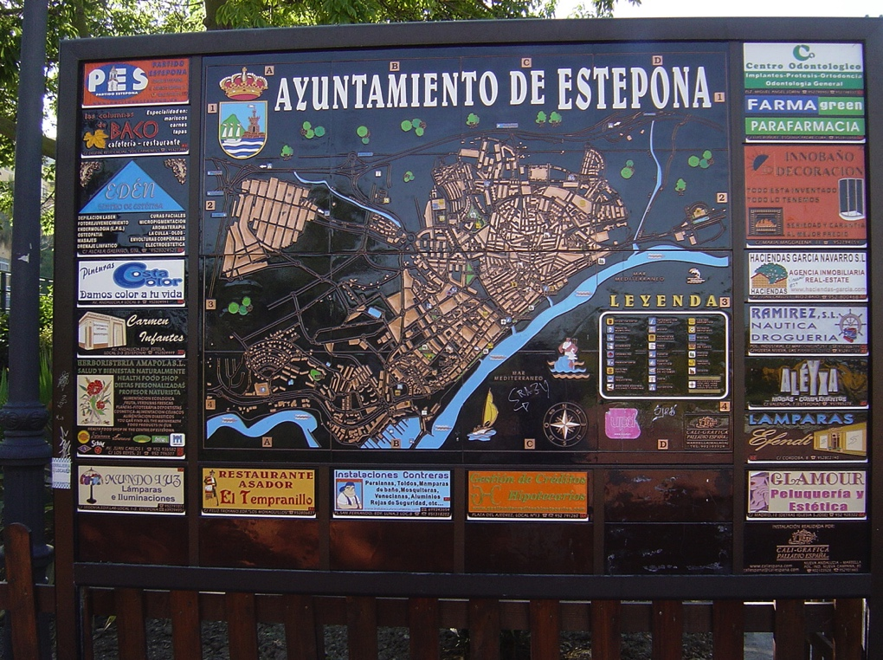

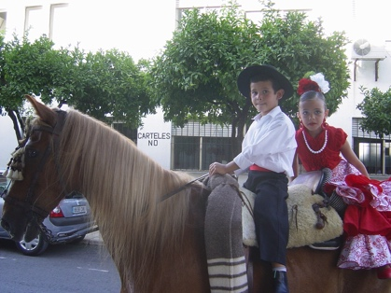

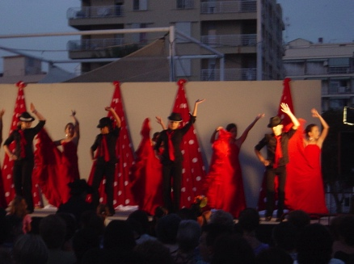

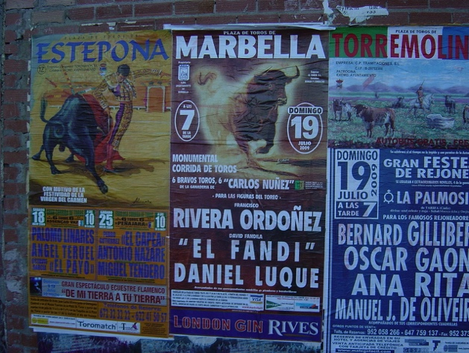

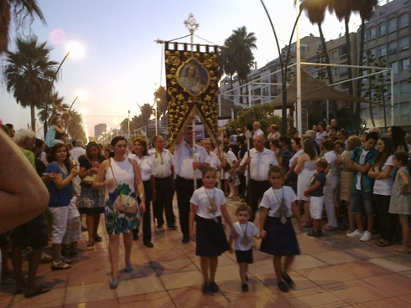

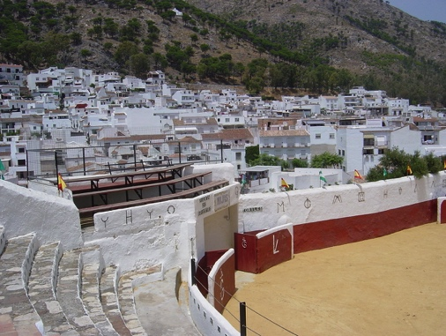
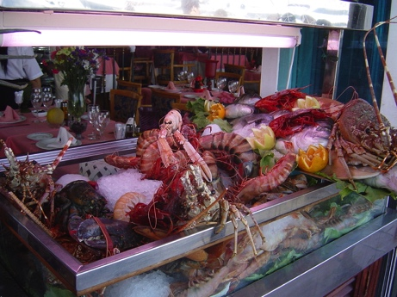

Appendix 4
SAMPLE LISTS FOR the Dossier (all 4 sections)

Sample list of mobility documents

Doc  No. | Title of the document  (short description) | Date | Language
1 | Europass CV *  (adapted for the application for work placement in Spain -Erasmus+ grant) | 15/05/2014 | EN, SI
2 | Letter of recommendation  (signed by Mr. …….., F&B manager) | 30/9/2014 | EN, ES
3 | Europass mobility  Period: 3 months, country: Spain  Host enterprise: Kempinski Hotel Bahia  Departement: Food & Beverage | 15/10/2014 | EN
4 | etc.

Sample list of materials about the host country

No. | Type of material  (short description) | Language
1 | Flyer with information about sightseeing:  Estepona, Ronda, Casares, Waterpark Selwo Marina | EN, ES
2 | City map of Estepona | EN
3 | Event calendar for July:  Feria  Procession of the Virgin Carmen | EN, ES, DE, FR
4 | Photos  Mijas, Bridge in Ronda, Marbella, Puerto Banus,
 | etc

Sample list of materials about the host company

No. | Type of material  (short description) | Language
1 | PPT- presentation of the company (handouts) | EN
2 | Information leaflets for the hotel guests  (invitation to gala dinner with flamenco show, excursions,…) | EN, ES, DE, FR
3 | Organisation structure of the company (chart) | EN, ES,
4 | Photos  restaurants, bar, pool bar,hotel lounge, laundry, cold kitchen, pastry department, uniforms, notice board, wellness reception…

Sample list of workplace-related materials

No. | Type of material  (short description) | Language
1 | Photos of my workplace  my team, new ingredients used for preparing dishes, Spanish national dishes, table decoration for wedding reception,... )
2 | Work safety regulations | EN, ES
3 | Recipes for Spanish dishes (gazpacho)  Recipes for new cocktails | EN, ES
4 | etc | EN, ES

